**Abstract**

This paper describes various dimension reduction techniques on the results of the National Health and Aging Trends Study (NHATS), a survey that is designed to understand the life of aging adults. Principal Component Analysis (PCA) and Factor Analysis (FA) were used to explore dimension reduction. Two Factor Analysis methods were utilized: principal component method and principal factor method. Orthogonal and oblique rotations were evaluated. Principal Component Analysis is superior to Factor Analysis for the data available.

**Data Preparation**

The NHATS dataset contains a response type variable used to identify patients answering for themselves. Only ‘sample person’ responses were analyzed. Table 1 shows 4,510 records were analyzed.

Table 1: Non-Proxy Respondents

|  |  |
| --- | --- |
| **is3resptype** | **Frequency** |
| Missing | 179 |
| Inapplicable | 213 |
| Sample Person | 4510 |
| Proxy | 897 |

Table 1 indicates missing values in the dataset. Due to time constraints, only complete variables were analyzed; all variables with missing responses were removed. (Please see the SAS code for proxy variable identification if desired). Table 2 indicates 132 variables are complete.

Table 2: Variable Missing Response Count

|  |  |  |  |  |
| --- | --- | --- | --- | --- |
| Category | Freq | Percent | Cum Freq | Cum Percent |
| Zero | 132 | 11.64 | 132 | 11.64% |
| 0.0-0.05 | 273 | 24.07 | 405 | 35.71% |
| 0.05-0.10 | 71 | 6.26 | 476 | 41.98% |
| 0.10-0.15 | 18 | 1.59 | 494 | 43.56% |
| 0.15-0.20 | 30 | 2.65 | 524 | 46.21% |
| 0.20-0.25 | 9 | 0.79 | 533 | 47.00% |
| 0.25-0.30 | 33 | 2.91 | 566 | 49.91% |
| 0.30-0.40 | 10 | 0.88 | 576 | 50.79% |
| 0.40-0.50 | 15 | 1.32 | 591 | 52.12% |
| Greater 0.5 | 543 | 47.88 | 1134 | 100.00% |

Table 3 identifies additional variables removed. Table 3: Additional Variable Removal

|  |  |
| --- | --- |
| **Variable** | **Reason** |
| Spid | ID variable not appropriate |
| is3resptype | Constant not appropriate |
| cg3todaydat5 | Date not appropriate |
| cg3todaydat6 | Date not appropriate |
| w3anfinwgt0-w3anfinwgt56 | Appears to be results of an analysis on the survey |
| w3varstrat | Appears to be results of an analysis on the survey |
| w3varunit | Appears to be results of an analysis on the survey |
| wa3dwlkadm | Appears to be results of an analysis on the survey |
| wc3dwaistadm | Appears to be results of an analysis on the survey |

PCA and FA were performed on 67 variables.

**Part A: Most Interpretable Analysis, Principal Component Analysis**

PCA yielded the most interpretable output. The primary advantage of PCA is utilizing an orthogonal rotation preserving the original axes’ 90-degree intersection. PCA oblique rotations were not considered.

Proportion of variance explained and a scree plot were used to determine the number of principal components utilized. The scree plot indicates three components explaining22.08% of the variance. The typical 80% cutoff is not achieved until the 34th component. The marginal increases to variance explained after three components are not significant enough to include additional variables.

Figure 1: Scree Plot for PCA

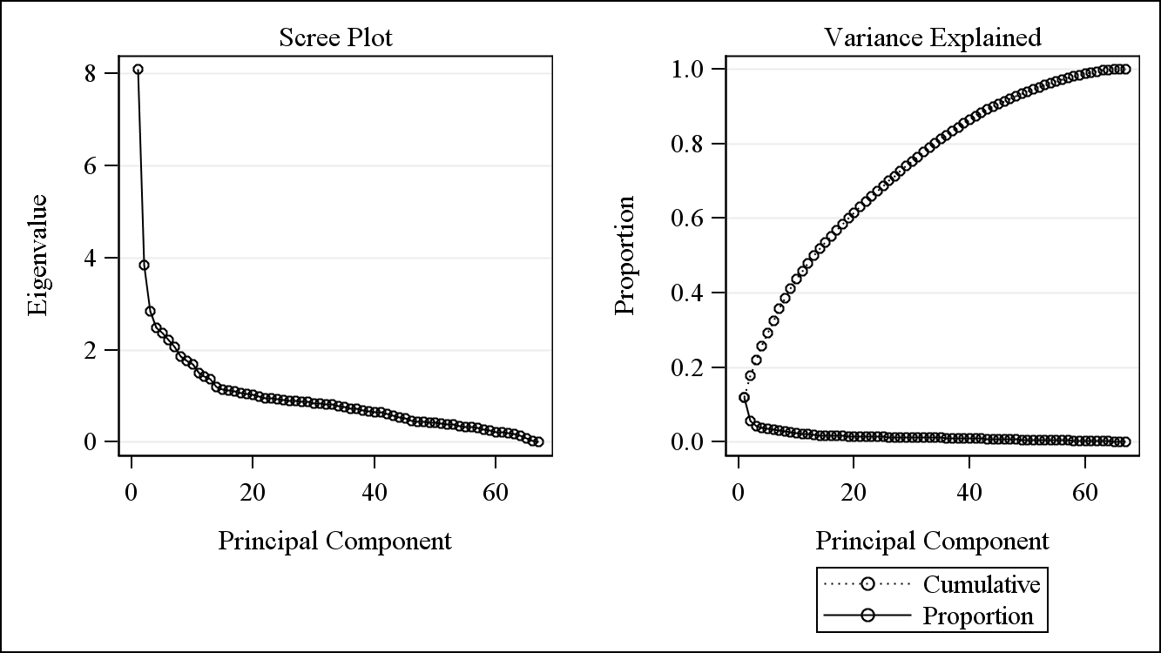

Table 4: PCA Eigenvalues of the Correlation Matrix

|  |  |  |  |  |
| --- | --- | --- | --- | --- |
|  | Eigenvalue | Difference | Proportion | Cumulative |
| 1 | 8.10443241 | 4.26088803 | 0.121 | 0.121 |
| 2 | 3.84354438 | 0.99720043 | 0.0574 | 0.1783 |
| 3 | 2.84634395 | 0.36360199 | 0.0425 | 0.2208 |
| 4 | 2.48274197 | 0.11609628 | 0.0371 | 0.2579 |
| 5 | 2.36664569 | 0.1406731 | 0.0353 | 0.2932 |
| 6 | 2.22597259 | 0.1528232 | 0.0332 | 0.3264 |
| 7 | 2.07314939 | 0.2150905 | 0.0309 | 0.3574 |
| 8 | 1.85805889 | 0.09958468 | 0.0277 | 0.3851 |
| 9 | 1.75847422 | 0.0711056 | 0.0262 | 0.4113 |
| 10 | 1.68736862 | 0.18340598 | 0.0252 | 0.4365 |
| 11 | 1.50396263 | 0.07480332 | 0.0224 | 0.459 |
| 12 | 1.42915932 | 0.0588168 | 0.0213 | 0.4803 |
| 13 | 1.37034251 | 0.17138215 | 0.0205 | 0.5007 |
| 14 | 1.19896036 | 0.05373733 | 0.0179 | 0.5186 |
| 15 | 1.14522303 | 0.0317402 | 0.0171 | 0.5357 |
| 16 | 1.11348283 | 0.01216687 | 0.0166 | 0.5524 |
| 17 | 1.10131596 | 0.0316017 | 0.0164 | 0.5688 |
| 18 | 1.06971427 | 0.01582539 | 0.016 | 0.5848 |
| 19 | 1.05388888 | 0.02873123 | 0.0157 | 0.6005 |
| 20 | 1.02515765 | 0.02984417 | 0.0153 | 0.6158 |
| 21 | 0.99531348 | 0.03519187 | 0.0149 | 0.6306 |
| 22 | 0.96012161 | 0.00329527 | 0.0143 | 0.645 |
| 23 | 0.95682633 | 0.02170117 | 0.0143 | 0.6593 |
| 24 | 0.93512516 | 0.02242507 | 0.014 | 0.6732 |
| 25 | 0.91270009 | 0.00799147 | 0.0136 | 0.6868 |
| 26 | 0.90470862 | 0.01428631 | 0.0135 | 0.7003 |
| 27 | 0.89042231 | 0.01045968 | 0.0133 | 0.7136 |
| 28 | 0.87996263 | 0.00503824 | 0.0131 | 0.7268 |
| 29 | 0.87492439 | 0.02732821 | 0.0131 | 0.7398 |
| 30 | 0.84759618 | 0.01264904 | 0.0127 | 0.7525 |
| 31 | 0.83494714 | 0.0121947 | 0.0125 | 0.7649 |
| 32 | 0.82275245 | 0.00774509 | 0.0123 | 0.7772 |
| 33 | 0.81500735 | 0.03093115 | 0.0122 | 0.7894 |
| 34 | 0.78407621 | 0.02142532 | 0.0117 | 0.8011 |

Table 5 shows the first component’s loadings. The color coding (Green=High; Yellow=Moderate; Red=Low) suggests no cross-loadings with the other two components. Variables loaded on the first component relate to the individual’s balance and movement. The first component was named “Balance/Mobility”.

Table 5: Loadings for Component 1

|  |  |  |  |  |
| --- | --- | --- | --- | --- |
| **Original Variables** | | **Prin1** | **Prin2** | **Prin3** |
| mo3dinsddevi | R3 D MOVE INSIDE WITH DEVICES | 0.243157 | 0.015635 | 0.030634 |
| ba3dblftadm | R3 D BALANCE FULL TANDEM ADMIN | 0.241131 | 0.02113 | -0.1458 |
| ba3dblstadm | R3 D BALANCE SEMI TANDEM ADMIN | 0.23886 | 0.026577 | -0.18704 |
| sc3dbathhelp | R3 D HAS HELP WHILE BATHING | 0.23543 | 0.044858 | 0.000795 |
| mo3doutdevi | R3 D GO OUTSIDE USING DEVICES | 0.232603 | 0.025178 | 0.025245 |
| ch3drchradm | R3 D REPEAT CHAIR ADMIN | 0.232251 | 0.038432 | -0.14685 |
| ch3dschradm | R3 D SINGLE CHAIR ADMIN | 0.214467 | 0.041418 | -0.2161 |
| ba3dblssadm | R3 D BALANCE SIDE BY SIDE ADMIN | 0.213311 | 0.037197 | -0.22803 |
| mo3douthelp | R3 D GO OUTSIDE USING HELP | 0.206145 | 0.057931 | -0.00065 |

Table 6 shows the second component’s loadings. No cross-loading appear with the other two components. Variables loaded on the second component relate to the individual’s household and family size. The second component was named “Household/Family Size”.

Table 6: Loadings for Component 2

|  |  |  |  |  |
| --- | --- | --- | --- | --- |
| **Original Variables** | | **Prin1** | **Prin2** | **Prin3** |
| hh3dlvngarrg | R3 D LIVING ARRANGEMENT | 0.008616 | 0.324399 | -0.08289 |
| hh3dhshldnum | R3 D TOTAL NUMBER IN HOUSEHOLD | -0.0119 | 0.30869 | -0.09222 |
| hh3dhshldchd | R3 D TOTAL CHILDREN IN HOUSEHOLD | 0.029299 | 0.263683 | -0.06513 |
| cs3dnumchild | R3 D NUMBER OF CHILDREN | 0.004973 | 0.191259 | -0.0091 |
| cs3dnumdaugh | R3 D NUMBER OF DAUGHTERS | 0.014425 | 0.148269 | -0.01082 |
| cs3dnumson | R3 D NUMBER OF SONS | -0.00682 | 0.14089 | -0.00298 |

Table 7 shows the third component’s loadings. No cross-loading appear with the other two components. Variables loaded on the third component relate to the individual’s daily ability to take care of themselves. The third principal was named “Basic Care”.

Table 7: Loadings for Component 3

|  |  |  |  |  |
| --- | --- | --- | --- | --- |
| **Original Variables** | | **Prin1** | **Prin2** | **Prin3** |
| sc3ddressfdf | R3 D DIFF LEVEL DRESSING SELF | 0.086347 | 0.0818 | 0.356976 |
| sc3ddresdevi | R3 D USES DEVICES WHILE DRESSING | 0.089676 | 0.061617 | 0.290535 |
| sc3dbathsfdf | R3 D DIFF BATHING SELF NO HELP | 0.011438 | 0.05149 | 0.28953 |
| sc3dtoilsfdf | R3 D DIFF LEVEL TOILETING SELF | 0.095177 | 0.08114 | 0.265979 |
| mo3dbedsfdf | R3 D GET OUT OF BED | 0.08032 | 0.072452 | 0.259304 |
| sc3deatsfdf | R3 D DIFF EATING BY SELF WO HELP | 0.108138 | 0.071426 | 0.238821 |

In summary, the PCA generates orthogonal components. Three components were selected to represent the 67 variables. These three components explain about 22% of the variance in the 67 variables. Since adding additional components marginally increased the variance proportion explained, three components were utilized, supported by the scree plot above. No cross-loadings occurred across components. With no cross-loadings, the constructs allowed for simple component interpretation.

**Part B: Compare and Contrast the Various Techniques**

As stated in the abstract, several dimension reduction techniques were explored. This section seeks to explain similarities and differences of the various techniques.

Figure 2 through Figure 4 compares the scree plots for the PCA and the FA with two different extraction methods. Figures 2 and 3 are identical. Figure 3 differs with less distinction between factors three and four. Consequently, the PCA and the FA (principal component method) agree, extracting three components/factors. The FA (principal factor method) extracted two components. **Note that the issue of proportion of variance explained is similar to the PCA for both FAs (see appendix proportion of variance explained tables if desired).**

Figure 2: Scree Plot for PCA



Figure 3: Scree Plot for FA (Principle Component Method)

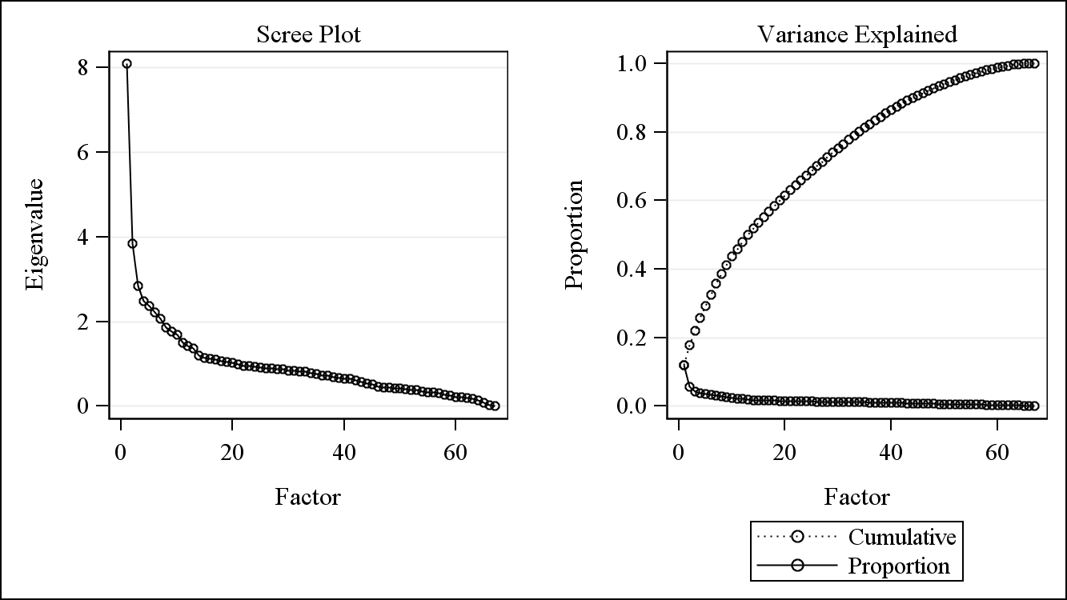

Figure 4: Scree Plot for FA (Principle Factor Method)

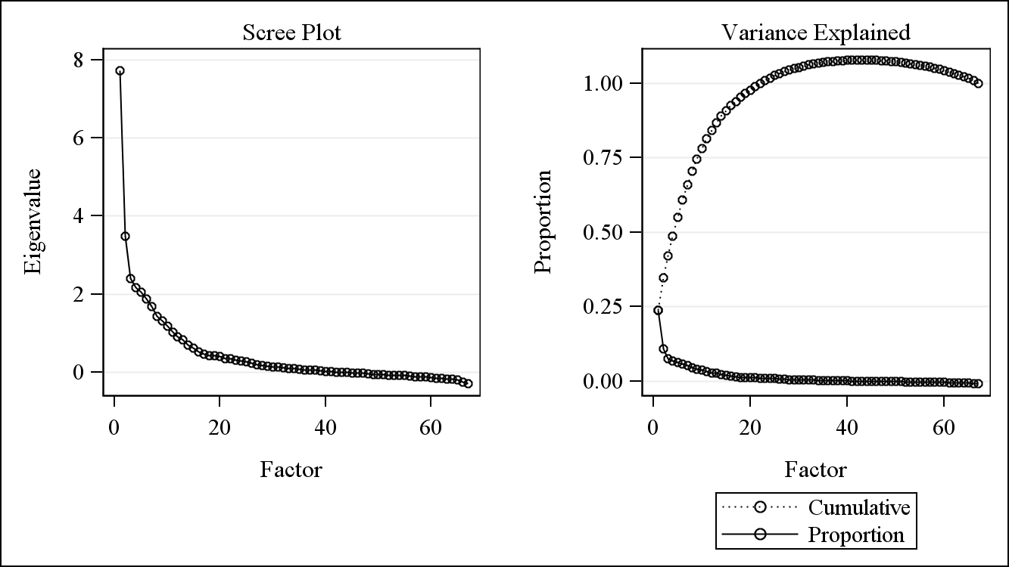

Each technique identified similar constructs. However, the constructs varied depending on analysis type (PCA or FA) and the number of components selected (the FA with 3 factors had slightly different constructs than the FA with 2 factors).

The FA (principal components method) with an orthogonal rotation resulted in three factors extracted. Factors one and two had three variables that were cross-loaded (R3 D MOVE INSIDE WITH DEVICES, R3 D GO OUTSIDE USING DEVICES, and R3 D HAS HELP WHILE BATHING) making factor naming somewhat difficult. Table 8 shows factor loadings. Respectively, factor names are “Balance/Mobility”, “Basic Care”, and “Living Situation”.

The FA (principal components method) with an oblique rotation resulted in three factors extracted. Factors one and three had three variables that were cross-loaded (R3 D MOVE INSIDE WITH DEVICES, R3 D GO OUTSIDE USING DEVICES, and R3 D HAS HELP WHILE BATHING) making factor naming somewhat difficult. given the constructs appearing in both factors. Table 9 shows factor loadings. Respectively, factor names are “Balance/Mobility”, “Living Situation”, and “Basic Care”.

Orthogonal and oblique rotations yielded cross-loadings with similar underlying factor constructs, although the order changes (see the factor names for factors 2 and 3 on each rotation). The FA underlying constructs are similar to PCA’s except for “Household/Family Size” (PCA) and “Living Situation” (FA).

Table 8: Factor Analysis (Principal Component Method) Varimax Rotation Loadings

|  |  |  |  |  |
| --- | --- | --- | --- | --- |
| **Principal Component Method Varimax: Rotated Factor Pattern** | | | | |
| **Variables** | | **Factor1** | **Factor2** | **Factor3** |
| ba3dblstadm | R3 D BALANCE SEMI TANDEM ADMIN | 0.73954 | 0.10285 | 0.08479 |
| ba3dblssadm | R3 D BALANCE SIDE BY SIDE ADMIN | 0.72131 | 0.01224 | 0.04049 |
| ch3dschradm | R3 D SINGLE CHAIR ADMIN | 0.71414 | 0.03236 | 0.03521 |
| ba3dblftadm | R3 D BALANCE FULL TANDEM ADMIN | 0.70476 | 0.16156 | 0.10325 |
| ch3drchradm | R3 D REPEAT CHAIR ADMIN | 0.69017 | 0.15415 | 0.0642 |
| sc3dbathhelp | R3 D HAS HELP WHILE BATHING | 0.56182 | 0.36775 | 0.07781 |
| ba3dblopadm | R3 D BALANCE 1 LEG OP EYE ADMIN | 0.54851 | 0.15885 | 0.11217 |
| mo3dinsddevi | R3 D MOVE INSIDE WITH DEVICES | 0.54333 | 0.40873 | 0.14323 |
| mo3doutdevi | R3 D GO OUTSIDE USING DEVICES | 0.52657 | 0.38956 | 0.11702 |
| mo3dbedhelp | R3 D HELP TO GET OUT OF BED | 0.51139 | 0.26718 | -0.01122 |
| mo3douthelp | R3 D GO OUTSIDE USING HELP | 0.49874 | 0.32787 | 0.03261 |
| sc3dtoilhelp | R3 D HAS HELP WHILE TOILETING | 0.49039 | 0.264 | 0.02888 |
| mo3dinsdhelp | R3 D MOVE INSIDE WITH HELP | 0.46837 | 0.34108 | 0.02566 |
| mo3dbeddevi | R3 D DEVICE USE 2 GET OUT OF BED | 0.44116 | 0.33094 | 0.0561 |

|  |  |  |  |  |
| --- | --- | --- | --- | --- |
| **Variables** | | **Factor1** | **Factor2** | **Factor3** |
| sc3ddressfdf | R3 D DIFF LEVEL DRESSING SELF | -0.10711 | 0.66025 | -0.03818 |
| sc3ddreshelp | R3 D HAS HELP WHILE DRESSING | 0.23071 | 0.61092 | -0.0569 |
| sc3ddresdevi | R3 D USES DEVICES WHILE DRESSING | -0.04339 | 0.56398 | -0.00829 |
| sc3dtoilsfdf | R3 D DIFF LEVEL TOILETING SELF | -0.00185 | 0.54591 | -0.04537 |
| sc3deatsfdf | R3 D DIFF EATING BY SELF WO HELP | 0.05082 | 0.52311 | -0.02237 |
| mo3dbedsfdf | R3 D GET OUT OF BED | -0.03287 | 0.51102 | -0.04025 |
| mo3dinsdsfdf | R3 D MOVE INSIDE SELF | 0.10391 | 0.51095 | 0.00383 |
| sc3dbathsfdf | R3 D DIFF BATHING SELF NO HELP | -0.22798 | 0.44272 | -0.04332 |
| mo3dinsddevi | R3 D MOVE INSIDE WITH DEVICES | 0.54333 | 0.40873 | 0.14323 |
| mo3doutdevi | R3 D GO OUTSIDE USING DEVICES | 0.52657 | 0.38956 | 0.11702 |
| sc3dbathhelp | R3 D HAS HELP WHILE BATHING | 0.56182 | 0.36775 | 0.07781 |

|  |  |  |  |  |
| --- | --- | --- | --- | --- |
| **Principal Component Method Varimax: Rotated Factor Pattern** | | | | |
| **Variables** | | **Factor1** | **Factor2** | **Factor3** |
| r3dresid | R3 D RESIDENTIAL CARE STATUS | 0.30321 | 0.07174 | 0.72094 |
| r2dresid | R2 D RESIDENTIAL CARE STATUS | 0.17627 | 0.05828 | 0.67861 |
| fl3hotype | R3 F RE HT TYPE OF HOME | 0.22451 | 0.05105 | 0.65303 |
| r1dresid | R1 D RESIDENTIAL CARE STATUS | 0.09795 | 0.02918 | 0.61536 |
| fl3structure | R3 F RE STRUCTURE OF SP DWELLING | 0.17103 | 0.09872 | 0.6075 |
| re3dresistrct | R3 D RESIDNCE PHYSICAL STRCTUR | 0.14559 | 0.0999 | 0.41032 |

Table 9: Factor Analysis (Principal Component Method) HK rotation Loadings

|  |  |  |  |  |
| --- | --- | --- | --- | --- |
| **Variables** | | **Factor1** | **Factor2** | **Factor3** |
| ba3dblstadm | R3 D BALANCE SEMI TANDEM ADMIN | 0.74059 | 0.17125 | 0.15287 |
| ba3dblftadm | R3 D BALANCE FULL TANDEM ADMIN | 0.72626 | 0.19045 | 0.20903 |
| ch3drchradm | R3 D REPEAT CHAIR ADMIN | 0.70745 | 0.1496 | 0.20072 |
| ba3dblssadm | R3 D BALANCE SIDE BY SIDE ADMIN | 0.69314 | 0.11826 | 0.06132 |
| ch3dschradm | R3 D SINGLE CHAIR ADMIN | 0.69195 | 0.11384 | 0.08092 |
| sc3dbathhelp | R3 D HAS HELP WHILE BATHING | 0.6499 | 0.16619 | 0.40505 |
| mo3dinsddevi | R3 D MOVE INSIDE WITH DEVICES | 0.64906 | 0.23228 | 0.44452 |
| mo3doutdevi | R3 D GO OUTSIDE USING DEVICES | 0.62557 | 0.203 | 0.42431 |

|  |  |  |  |  |
| --- | --- | --- | --- | --- |
| **Variables** | | **Factor1** | **Factor2** | **Factor3** |
| r3dresid | R3 D RESIDENTIAL CARE STATUS | 0.36014 | 0.75263 | 0.09064 |
| r2dresid | R2 D RESIDENTIAL CARE STATUS | 0.23234 | 0.69604 | 0.06864 |
| fl3hotype | R3 F RE HT TYPE OF HOME | 0.27433 | 0.67528 | 0.06478 |
| fl3structure | R3 F RE STRUCTURE OF SP DWELLING | 0.23447 | 0.62819 | 0.10879 |
| r1dresid | R1 D RESIDENTIAL CARE STATUS | 0.14471 | 0.62268 | 0.03441 |
| re3dresistrct | R3 D RESIDNCE PHYSICAL STRCTUR | 0.1969 | 0.43012 | 0.10868 |

|  |  |  |  |  |
| --- | --- | --- | --- | --- |
| **Variables** | | **Factor1** | **Factor2** | **Factor3** |
| sc3ddressfdf | R3 D DIFF LEVEL DRESSING SELF | 0.09224 | 0.0027 | 0.65149 |
| sc3ddreshelp | R3 D HAS HELP WHILE DRESSING | 0.39782 | 0.0164 | 0.62536 |
| sc3ddresdevi | R3 D USES DEVICES WHILE DRESSING | 0.12627 | 0.03156 | 0.55973 |
| sc3dtoilsfdf | R3 D DIFF LEVEL TOILETING SELF | 0.15785 | -0.00216 | 0.54462 |
| sc3deatsfdf | R3 D DIFF EATING BY SELF WO HELP | 0.20279 | 0.02447 | 0.5254 |
| mo3dinsdsfdf | R3 D MOVE INSIDE SELF | 0.25152 | 0.05516 | 0.51684 |
| mo3dbedsfdf | R3 D GET OUT OF BED | 0.11827 | -0.00316 | 0.50768 |
| mo3dinsddevi | R3 D MOVE INSIDE WITH DEVICES | 0.64906 | 0.23228 | 0.44452 |
| sc3dbathsfdf | R3 D DIFF BATHING SELF NO HELP | -0.08805 | -0.03245 | 0.42623 |
| mo3doutdevi | R3 D GO OUTSIDE USING DEVICES | 0.62557 | 0.203 | 0.42431 |
| sc3dbathhelp | R3 D HAS HELP WHILE BATHING | 0.6499 | 0.16619 | 0.40505 |

The FA (principal factor method) with an orthogonal rotation resulted in two factors extracted. No cross-loadings occur between these two factors but are suspected if more factors were kept. Table 10 shows factor loadings. Respectively, factor names are “Balance/Mobility/Basic Care” and “Living Situation”.

The FA (principal factor method) with an oblique rotation resulted in two factors extracted. No cross-loadings appear across the factors, but are suspected if more factors were kept. Table 11 shows factor loadings. Respectively, factor names are “Balance/Mobility/Basic Care” and “Living Situation”.

Given the FA (principal factor method) results, no cross loadings or factor names changes (underlying constructs) occur from rotation to rotation. Generally, the same three underlying constructs from FA (principal components method). The first component for Factor Analysis (principal factor method) appears to combine the “Balance/Mobility” and “Basic Care” constructs.

Table 10: Factor Analysis (Principal Factor Method) Varimax Rotation Loadings

|  |  |  |  |
| --- | --- | --- | --- |
| **Variables** | | **Factor1** | **Factor2** |
| ba3dblftadm | R3 D BALANCE FULL TANDEM ADMIN | 0.67257 | 0.1144 |
| ba3dblstadm | R3 D BALANCE SEMI TANDEM ADMIN | 0.67013 | 0.10253 |
| mo3dinsddevi | R3 D MOVE INSIDE WITH DEVICES | 0.66544 | 0.12642 |
| mo3doutdevi | R3 D GO OUTSIDE USING DEVICES | 0.66313 | 0.10111 |
| ch3drchradm | R3 D REPEAT CHAIR ADMIN | 0.64799 | 0.07684 |
| sc3dbathhelp | R3 D HAS HELP WHILE BATHING | 0.64241 | 0.07238 |
| ch3dschradm | R3 D SINGLE CHAIR ADMIN | 0.61861 | 0.05753 |
| ba3dblssadm | R3 D BALANCE SIDE BY SIDE ADMIN | 0.61376 | 0.06468 |
| mo3douthelp | R3 D GO OUTSIDE USING HELP | 0.60484 | 0.02143 |
| mo3dinsdhelp | R3 D MOVE INSIDE WITH HELP | 0.56214 | 0.01913 |
| mo3dbedhelp | R3 D HELP TO GET OUT OF BED | 0.55256 | -0.00587 |
| sc3dtoilhelp | R3 D HAS HELP WHILE TOILETING | 0.53497 | 0.03001 |
| ba3dblopadm | R3 D BALANCE 1 LEG OP EYE ADMIN | 0.53227 | 0.11461 |
| mo3dbeddevi | R3 D DEVICE USE 2 GET OUT OF BED | 0.5307 | 0.04794 |
| sc3ddreshelp | R3 D HAS HELP WHILE DRESSING | 0.52141 | -0.09173 |

|  |  |  |  |
| --- | --- | --- | --- |
| **Variables** | | **Factor1** | **Factor2** |
| r3dresid | R3 D RESIDENTIAL CARE STATUS | 0.29959 | 0.70681 |
| r2dresid | R2 D RESIDENTIAL CARE STATUS | 0.18654 | 0.6611 |
| fl3hotype | R3 F RE HT TYPE OF HOME | 0.2217 | 0.6414 |
| r1dresid | R1 D RESIDENTIAL CARE STATUS | 0.1048 | 0.59284 |
| fl3structure | R3 F RE STRUCTURE OF SP DWELLING | 0.20215 | 0.55675 |
| re3dresistrct | R3 D RESIDNCE PHYSICAL STRCTUR | 0.17897 | 0.37216 |

Table 11: Factor Analysis (Principal Factor Method) HK rotation Loadings

|  |  |  |  |
| --- | --- | --- | --- |
| **Variable** | | **Factor1** | **Factor2** |
| ba3dblftadm | R3 D BALANCE FULL TANDEM ADMIN | 0.66481 | 0.0715 |
| ba3dblstadm | R3 D BALANCE SEMI TANDEM ADMIN | 0.6639 | 0.05958 |
| mo3doutdevi | R3 D GO OUTSIDE USING DEVICES | 0.65701 | 0.05861 |
| mo3dinsddevi | R3 D MOVE INSIDE WITH DEVICES | 0.65602 | 0.0842 |
| ch3drchradm | R3 D REPEAT CHAIR ADMIN | 0.64489 | 0.03493 |
| sc3dbathhelp | R3 D HAS HELP WHILE BATHING | 0.63982 | 0.03077 |
| ch3dschradm | R3 D SINGLE CHAIR ADMIN | 0.61771 | 0.01726 |
| ba3dblssadm | R3 D BALANCE SIDE BY SIDE ADMIN | 0.61188 | 0.02485 |
| mo3douthelp | R3 D GO OUTSIDE USING HELP | 0.60853 | -0.01854 |
| mo3dinsdhelp | R3 D MOVE INSIDE WITH HELP | 0.56567 | -0.01803 |
| mo3dbedhelp | R3 D HELP TO GET OUT OF BED | 0.55926 | -0.04281 |
| sc3ddreshelp | R3 D HAS HELP WHILE DRESSING | 0.53902 | -0.12806 |
| sc3dtoilhelp | R3 D HAS HELP WHILE TOILETING | 0.53678 | -0.00516 |
| mo3dbeddevi | R3 D DEVICE USE 2 GET OUT OF BED | 0.53011 | 0.01337 |
| ba3dblopadm | R3 D BALANCE 1 LEG OP EYE ADMIN | 0.52297 | 0.08106 |

|  |  |  |  |
| --- | --- | --- | --- |
| **Variable** | | **Factor1** | **Factor2** |
| r3dresid | R3 D RESIDENTIAL CARE STATUS | 0.21023 | 0.69885 |
| r2dresid | R2 D RESIDENTIAL CARE STATUS | 0.10195 | 0.65991 |
| fl3hotype | R3 F RE HT TYPE OF HOME | 0.14007 | 0.63752 |
| r1dresid | R1 D RESIDENTIAL CARE STATUS | 0.02827 | 0.59593 |
| fl3structure | R3 F RE STRUCTURE OF SP DWELLING | 0.13139 | 0.55274 |
| re3dresistrct | R3 D RESIDNCE PHYSICAL STRCTUR | 0.13214 | 0.36656 |

In summary, the extraction method affected the number of factors selected. Consequently, the extraction method had affected the underlying constructs. Rotations produced marginal adjustments to results, had minimal impact on factor coefficient estimates, and failed to address cross-loading issues. In this case, the extraction method had the greatest impact on the results.

**Appendix**

Table 1A: Eigenvalues for Factor Analysis (Principal Component Method)

|  |  |  |  |  |
| --- | --- | --- | --- | --- |
| Eigenvalues of the Correlation Matrix: Total = 67 Average = 1 | | | | |
|  | Eigenvalue | Difference | Proportion | Cumulative |
| 1 | 8.10443241 | 4.26088803 | 0.121 | 0.121 |
| 2 | 3.84354438 | 0.99720043 | 0.0574 | 0.1783 |
| 3 | 2.84634395 | 0.36360199 | 0.0425 | 0.2208 |
| 4 | 2.48274197 | 0.11609628 | 0.0371 | 0.2579 |
| 5 | 2.36664569 | 0.1406731 | 0.0353 | 0.2932 |
| 6 | 2.22597259 | 0.1528232 | 0.0332 | 0.3264 |
| 7 | 2.07314939 | 0.2150905 | 0.0309 | 0.3574 |
| 8 | 1.85805889 | 0.09958468 | 0.0277 | 0.3851 |
| 9 | 1.75847422 | 0.0711056 | 0.0262 | 0.4113 |
| 10 | 1.68736862 | 0.18340598 | 0.0252 | 0.4365 |
| 11 | 1.50396263 | 0.07480332 | 0.0224 | 0.459 |
| 12 | 1.42915932 | 0.0588168 | 0.0213 | 0.4803 |
| 13 | 1.37034251 | 0.17138215 | 0.0205 | 0.5007 |
| 14 | 1.19896036 | 0.05373733 | 0.0179 | 0.5186 |
| 15 | 1.14522303 | 0.0317402 | 0.0171 | 0.5357 |
| 16 | 1.11348283 | 0.01216687 | 0.0166 | 0.5524 |
| 17 | 1.10131596 | 0.0316017 | 0.0164 | 0.5688 |
| 18 | 1.06971427 | 0.01582539 | 0.016 | 0.5848 |
| 19 | 1.05388888 | 0.02873123 | 0.0157 | 0.6005 |
| 20 | 1.02515765 | 0.02984417 | 0.0153 | 0.6158 |
| 21 | 0.99531348 | 0.03519187 | 0.0149 | 0.6306 |
| 22 | 0.96012161 | 0.00329527 | 0.0143 | 0.645 |
| 23 | 0.95682633 | 0.02170117 | 0.0143 | 0.6593 |
| 24 | 0.93512516 | 0.02242507 | 0.014 | 0.6732 |
| 25 | 0.91270009 | 0.00799147 | 0.0136 | 0.6868 |
| 26 | 0.90470862 | 0.01428631 | 0.0135 | 0.7003 |
| 27 | 0.89042231 | 0.01045968 | 0.0133 | 0.7136 |
| 28 | 0.87996263 | 0.00503824 | 0.0131 | 0.7268 |
| 29 | 0.87492439 | 0.02732821 | 0.0131 | 0.7398 |
| 30 | 0.84759618 | 0.01264904 | 0.0127 | 0.7525 |
| 31 | 0.83494714 | 0.0121947 | 0.0125 | 0.7649 |
| 32 | 0.82275245 | 0.00774509 | 0.0123 | 0.7772 |
| 33 | 0.81500735 | 0.03093115 | 0.0122 | 0.7894 |
| 34 | 0.78407621 | 0.02142532 | 0.0117 | 0.8011 |

Table 2A: Eigenvalues for Factor Analysis (Principal Factor Method)

|  |  |  |  |  |
| --- | --- | --- | --- | --- |
| **Eigenvalues of the Reduced Correlation Matrix: Total = 32.3955993 Average = 0.48351641** | | | | |
|  | **Eigenvalue** | **Difference** | **Proportion** | **Cumulative** |
| 1 | 7.73330704 | 4.23896275 | 0.2387 | 0.2387 |
| 2 | 3.49434429 | 1.08954725 | 0.1079 | 0.3466 |
| 3 | 2.40479704 | 0.24482524 | 0.0742 | 0.4208 |
| 4 | 2.1599718 | 0.10379065 | 0.0667 | 0.4875 |
| 5 | 2.05618115 | 0.18565635 | 0.0635 | 0.551 |
| 6 | 1.87052481 | 0.19085254 | 0.0577 | 0.6087 |
| 7 | 1.67967227 | 0.2414357 | 0.0518 | 0.6605 |
| 8 | 1.43823657 | 0.1215954 | 0.0444 | 0.7049 |
| 9 | 1.31664117 | 0.13323556 | 0.0406 | 0.7455 |
| 10 | 1.18340561 | 0.15368915 | 0.0365 | 0.782 |
| 11 | 1.02971646 | 0.11167301 | 0.0318 | 0.8138 |
| 12 | 0.91804345 | 0.07614242 | 0.0283 | 0.8421 |
| 13 | 0.84190103 | 0.15110322 | 0.026 | 0.8681 |
| 14 | 0.69079781 | 0.06639623 | 0.0213 | 0.8894 |
| 15 | 0.62440158 | 0.09343712 | 0.0193 | 0.9087 |
| 16 | 0.53096447 | 0.05971991 | 0.0164 | 0.9251 |
| 17 | 0.47124456 | 0.04644624 | 0.0145 | 0.9396 |
| 18 | 0.42479832 | 0.00671234 | 0.0131 | 0.9527 |
| 19 | 0.41808598 | 0.01849774 | 0.0129 | 0.9656 |
| 20 | 0.39958823 | 0.04419685 | 0.0123 | 0.9779 |
| 21 | 0.35539139 | 0.01500231 | 0.011 | 0.9889 |
| 22 | 0.34038908 | 0.02386483 | 0.0105 | 0.9994 |
| 23 | 0.31652425 | 0.03101839 | 0.0098 | 1.0092 |
| 24 | 0.28550586 | 0.01444408 | 0.0088 | 1.018 |
| 25 | 0.27106178 | 0.04748383 | 0.0084 | 1.0264 |
| 26 | 0.22357795 | 0.02711126 | 0.0069 | 1.0333 |
| 27 | 0.19646669 | 0.01686769 | 0.0061 | 1.0394 |
| 28 | 0.17959899 | 0.01702985 | 0.0055 | 1.0449 |
| 29 | 0.16256914 | 0.02428301 | 0.005 | 1.0499 |
| 30 | 0.13828613 | 0.0087325 | 0.0043 | 1.0542 |
| 31 | 0.12955363 | 0.01023608 | 0.004 | 1.0582 |
| 32 | 0.11931755 | 0.01735586 | 0.0037 | 1.0619 |
| 33 | 0.10196169 | 0.01138343 | 0.0031 | 1.065 |
| 34 | 0.09057826 | 0.00477873 | 0.0028 | 1.0678 |

**SAS Code**